Cleveland Heights considers citywide tax incentive program for new construction, home renovations
By Chanda Neely, Northeast Ohio Media Group
on May 02, 2014 at 5:20 PM, updated May 02, 2014 at 6:33 PM
CLEVELAND HEIGHTS, Ohio –- City officials are mulling the idea of offering tax incentives to all residents who build new homes, or who make renovations that increase their current home values.
Tax abatements would be offered only on the difference between the original value and the increased amount.
"The goal is to encourage investment in our current housing, like increased living conditions through an addition," City Planner Karen Knittel said. "We also want to make sure that we preserve our historic district and historic houses that are still in good condition."
Knittel said the city last year approved 22 permits for housing projects that could have possibly qualified for a tax break.
What do you think about the idea of offering a citywide tax incentive program?
City officials threw around the idea of offering a five-year citywide incentive during a meeting Monday. But Councilman Jeff Coryell said the incentive should only go to areas with higher vacancy rates and where residents have lower incomes.
Council members Jason Stein and Mary Dunbar disagreed.
"We need to be fair because we have so many pockets in the community that really need assistance," Stein said.
"I don't think you want to discourage renovations anywhere," Dunbar said.
The city's vacancy rate ranges from 35 to 65 percent near the East Cleveland border, where the poverty rate is 43 percent and the median income is less than $24,000, according to maps provided by the city. Areas near Fairmount Boulevard have a similar vacancy rate, though the median income is greater than $50,000. (See maps below.)
City Council in March approved 100 percent tax abatement for a maximum of 15 years for new housing construction and repairs of existing homes in parts of Edgehill and Overlook roads and Kenilworth Mews in an area known as Turkey Ridge. City officials said the Turkey Ridge talks sparked debate about a possible citywide incentive.
That development lies in an area with a $34,450 median income and vacancy rate between 6 to 18 percent.
City officials have not decided if they will offer a 100-percent or a lower abatement, in all or some areas. City Manager Tanisha Briley said she is looking to Lakewood and South Euclid, which have similar programs called community reinvestment areas, and will bring her findings back to City Council for a later discussion.
South Euclid Community Services Director Keith Benjamin said the city has attracted more than $26 million in new residential construction and renovations, and the number of vacant and foreclosed homes has dropped by more than 50 percent, due in part to the citywide community reinvestment area Council approved in 2008. The number of homes with market rate values of more than $100,000 also has increased in the last four years.
"Providing opportunities for reinvestment in our neighborhoods is critical to maintaining our current tax base," Benjamin said. "And by offering a citywide incentive, you are leveling the playing field."
Cleveland Heights already offers tax incentives in the Villa Carabelli, Lee-Euclid Heights, Severance, Cain Park, East Derbyshire and Meadowbrook-Lee areas.
"This is just initial brainstorming," Briley said about a possible citywide incentive. "It's the beginning of a much longer discussion."
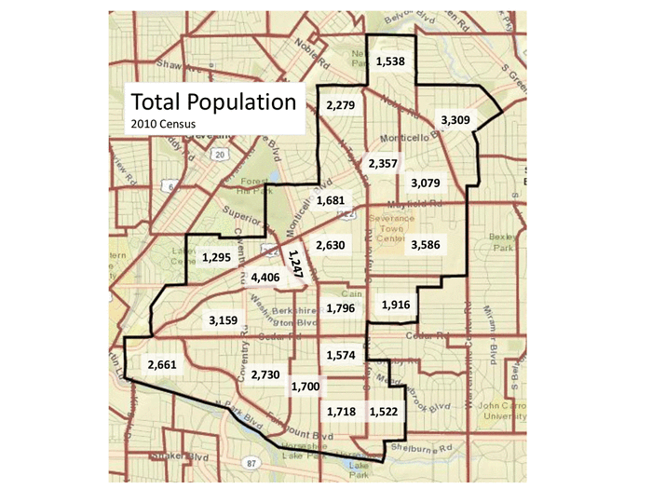
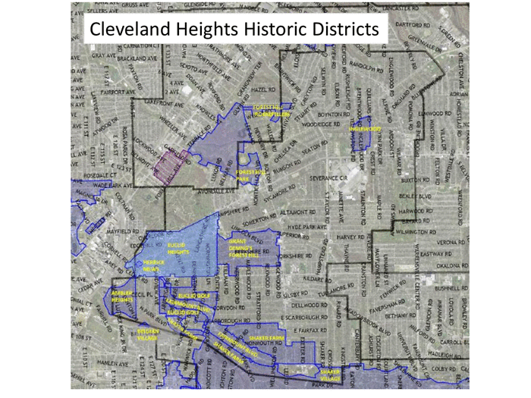
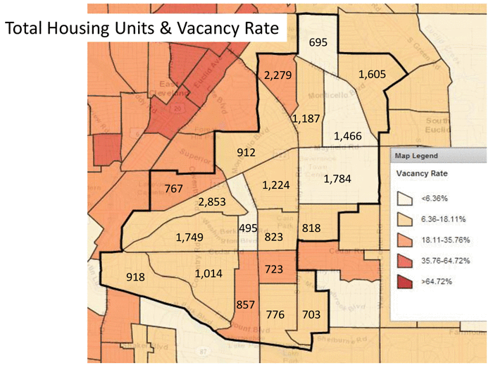

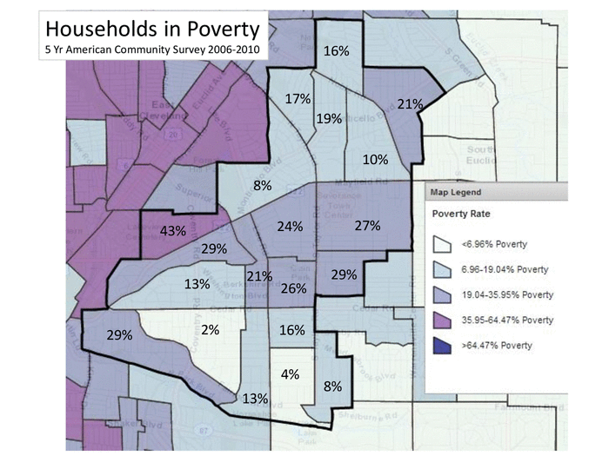
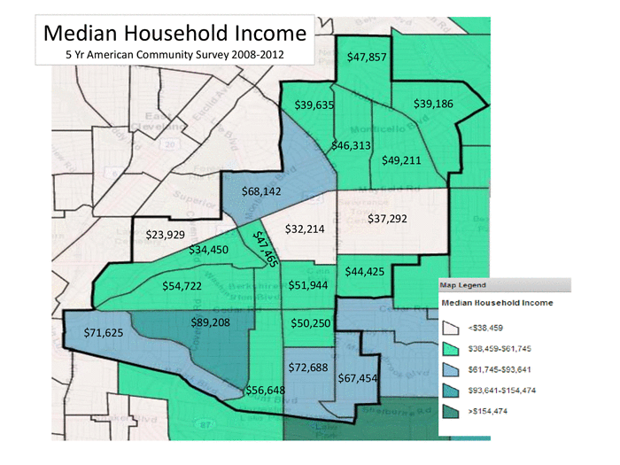

16
