Embracing the existing character of a neighborhood:

Adaptive reuse of older buildings can be a practical solution in some cases. Here are a few google maps links showing examples from the Beers and Gears District in Durham, NC. Notice how the new businesses embrace the light industrial character of the area. Also notice how the street edge is defined by onstreet parking (at peak use) and by outdoor seating along the sidewalk; this improves the pedestrian experience (walkability). The clustering of the new business creates a sense of place in an unconventional, but effective, way.

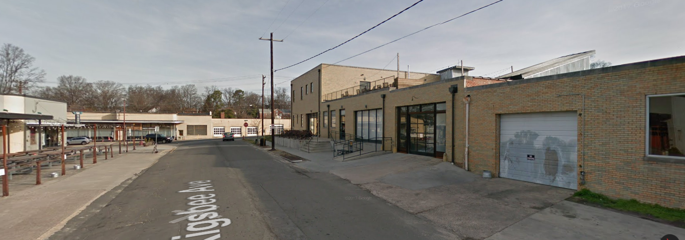
Light industrial converted into BBQ with rooftop dining area
Link to Google: http://bit.ly/2smfXWS

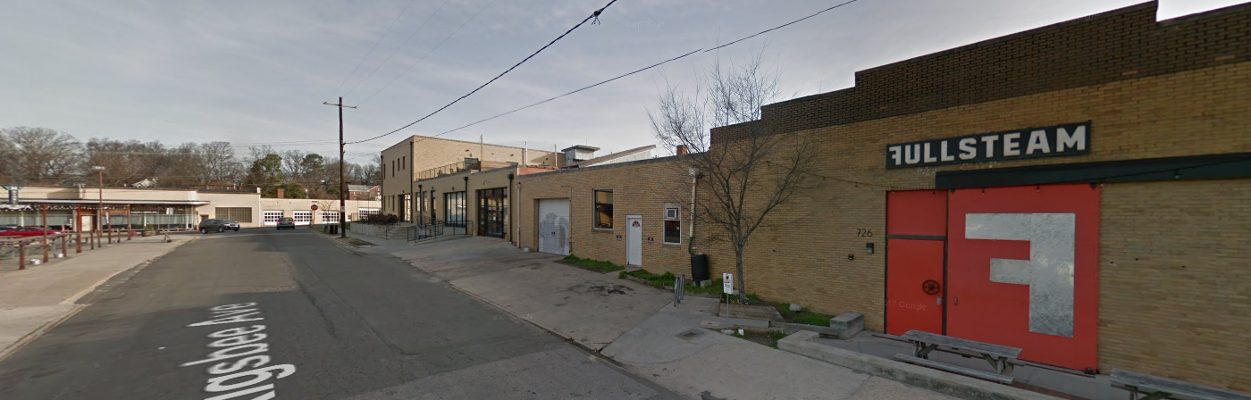

Light industrial shop converted into a brewery
Link to Google: http://bit.ly/2toJxJu

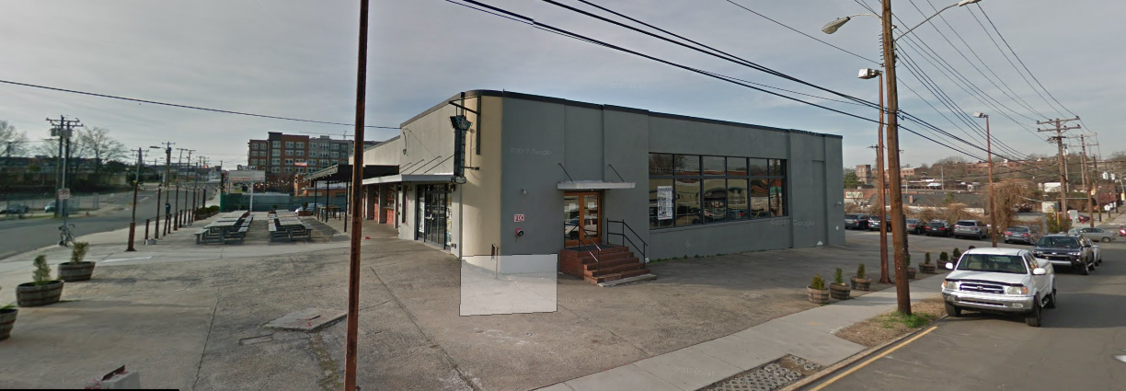

Motor company converted into a music venture
Link to Google: http://bit.ly/2sSdX9z

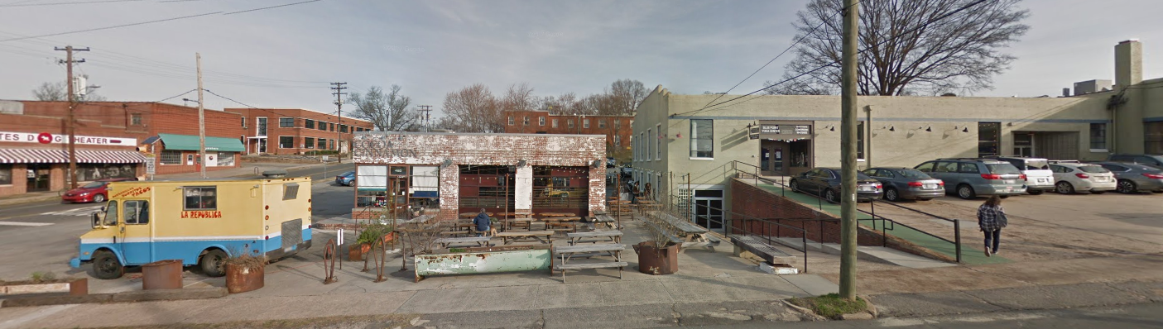

Gas station converted into a bar and grill with outdoor seating.
Link to Google: http://bit.ly/2sRQ8iw

